1. Create Dockerfile

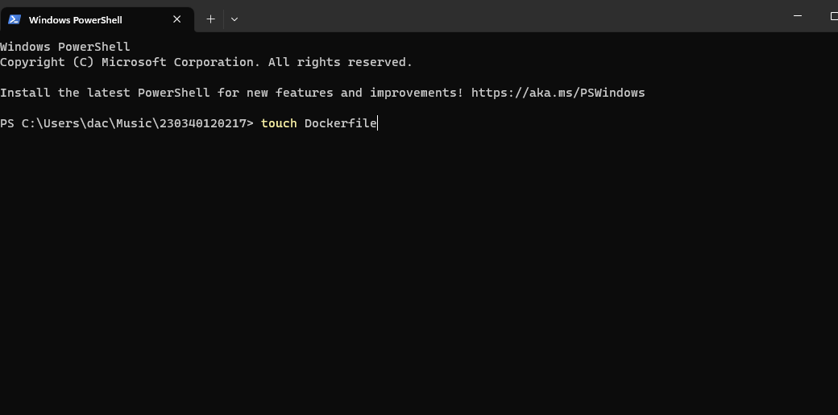

1. Add all the instruction for docker to run Contenarize the application anywhere and create its Image

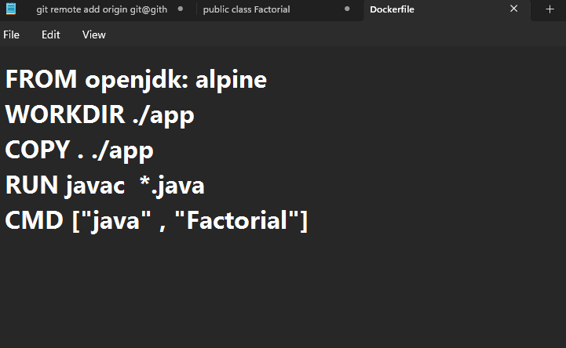

1. Build the image using docker
2. 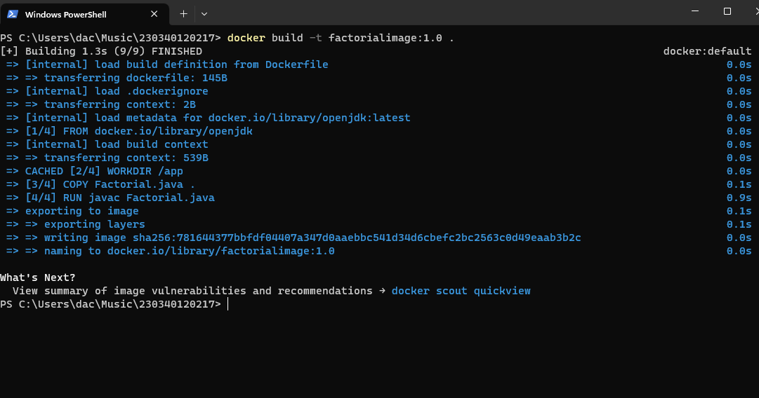
3. After building run the image using docker run
4. 